© Copyright Broadsword Interactive 1997/1998

Spirit Of Speed Architecture
An overview of the architecture of “Spirit of Speed” based on the Boris 3D engine.

Jim Finnis (jcf@broadsword.demon.co.uk)
Revision: 1.6

Created: 12/1/98
Last Revised: 10/3/98
Document State: Draft

Overall Game Architecture
This document describes the overall architecture of “Spirit of Speed”. This draft version of the document is intended for discussion, and changes from the discussion should be merged back into the document.

The game is designed to operate in two threads - one thread does the actual game code, and putting instructions into display lists for rendering; while the other thread simply renders the next available display list. The game thread runs in a similar manner to an interrupt, every 30th of a second.

Game Block Diagram
This diagram shows the main functional parts into which the game divides. Like everything else, it’s subject to change. The small boxes with the initial indicate the person who is primarily responsible for that section.

Main Game Framework Code (main.cpp, game.cpp)
The main program follows the sequence below (you’ll need to read the Boris docs to understand a lot of this):

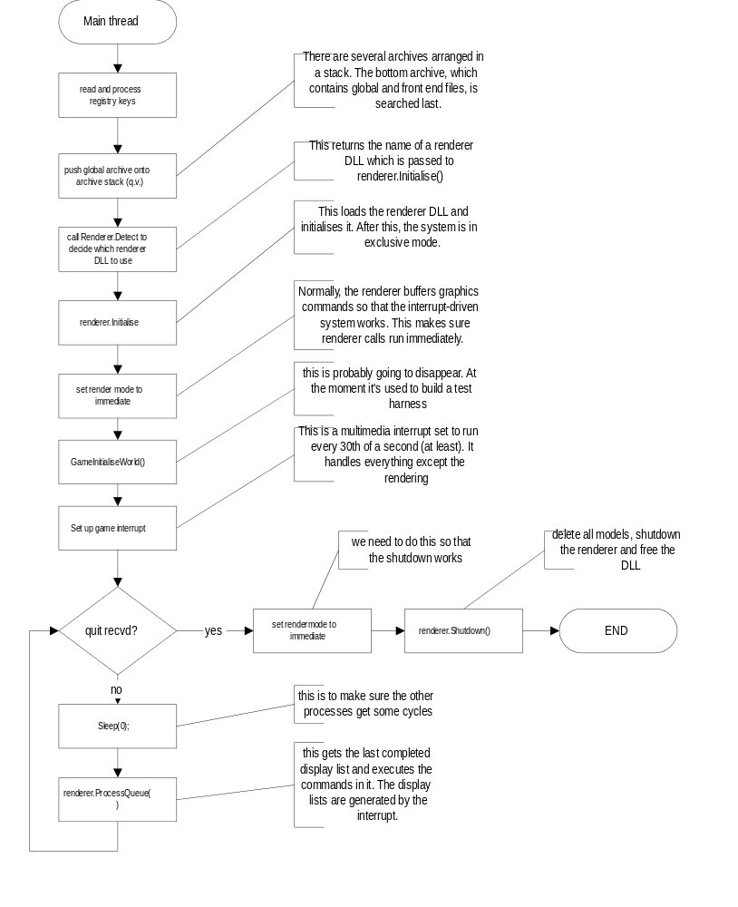

Interrupt (thread.cpp, game.cpp)
This isn’t really an interrupt; it’s actually a thread which spends (hopefully) most of its time sleeping. It deals with all the game’s processing apart from the actual rendering. It looks (in a very simple form) like this:
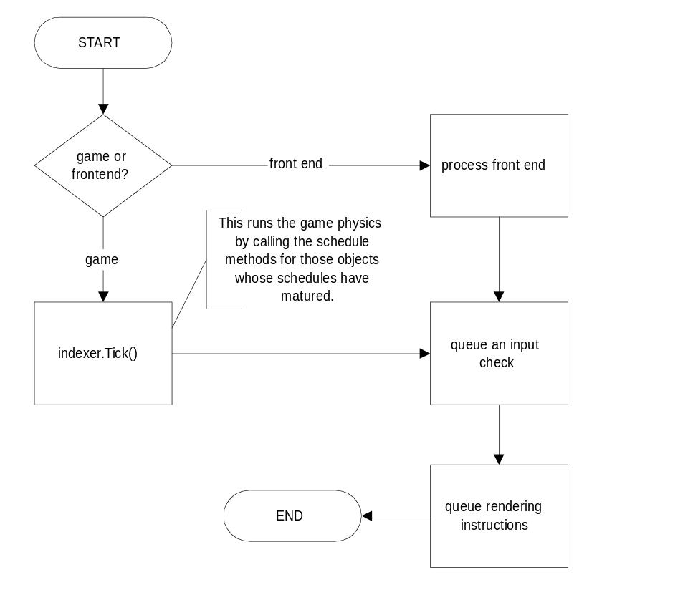
There’s a rather more complete flowchart of the interrupt appended to this document. Currently it’s not finished, of course.

BORIS
Boris - the Broadsword Object Rendering and Interaction System - is a comprehensive multiplatform 3D engine. It divides the game environment into two separate sections - World (consisting of static polygons) and Objects (consisting of a hierarchy of 3D objects which may, or may not, have renderable models assigned to them). Objects and parts of the world can be rendered at different levels of detail depending on their distance from the camera. Objects can also have schedules of various different kinds attached to them, so they can perform periodic actions.

Rendering is done by queuing display list instructions, which are either immediately passed down to the rendering DLL or queued in a display list until the end of a frame. All hardware dependent code is in a rendering DLL, so new hardware drivers can quickly be produced independently of Boris.

For more details see the Boris API documentation.

Detection DLL
The detection DLL is loaded when Boris starts, and uses several hardware-dependent strategies to determine which renderer DLL should be used. It has a single function, which returns the name of a renderer DLL to load. The DLL is then freed.

Renderer DLL’s
Boris does no rendering itself. Instead, it passes instructions down to a renderer DLL. There may be more than one renderer DLL; the detection DLL will look at the hardware on the machine and tell Boris which DLL to load. Boris then communicates with the DLL through one function, using a simple protocol which is detailed in the Boris documentation.

Front End (not yet implemented)
The front end incorporates 4 elements:

- 2D backdrop image
- 2D clickable areas
- 3D objects
- FMV segments, both fullscreen and transparent partial screen

The front end works by using a table of actions, each of which represents an FMV segment, a new menu screen, quitting the game, or starting the main game section. The first action is preset to be the intro FMV. Menu actions do two things: they can modify the data blocks, and they can transfer control to a new action. Essentially, then, the front end loop looks like this:
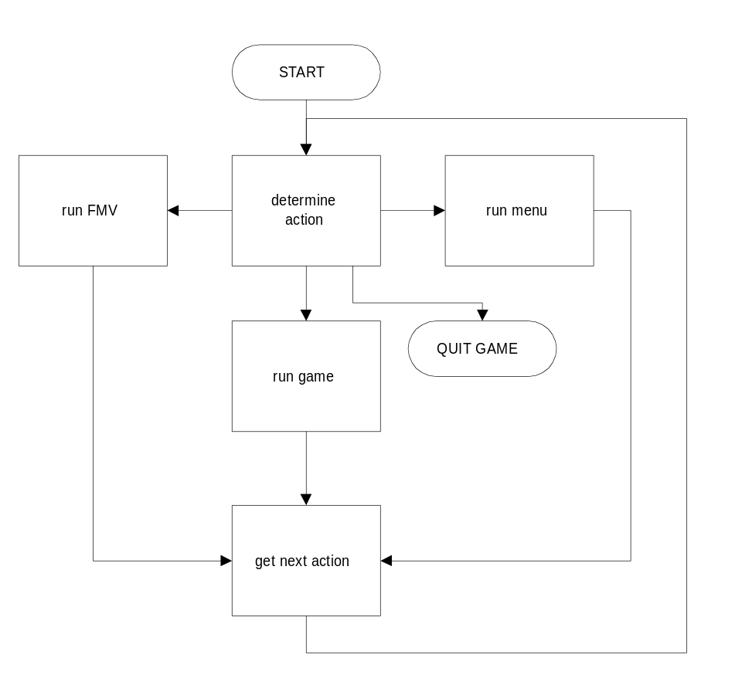

An action table will probably have the following format:

typedef enum { ACT_MENU, ACT_QUIT, ACT_GAME, ACT_FMV } front_end_action;

/* see below for details of the arguments passed to this function */

typedef int (*menufunction)(struct player_data *p, struct front_end_data *f);

struct front_end_table
{
char *name; /* name of state, for debugging purposes */
front_end_action action;
union
{
char *fmv_name;
menufunction menu;
};
int next_action; /* used for all except ACT_MENU and ACT_QUIT */
};

ACT_QUIT action don’t require a next_action because there is no next action after you’ve quit. ACT_MENU doesn’t require one because the menu function itself determines the next action.

The zeroth action in the table is the starting action.

An example table could be:

struct front_end_table fe_table={
{“START”,ACT_FMV, “intro.fmv”, 1}, // intro leads to action 1
{“MENU1”,ACT_MENU, main_menu_func, 0}, // 0 is ignored here
{“INTRO”,ACT_FMV, “game.fmv”, 3}, // called by menu, leads into game
{“GAME”.ACT_GAME, NULL, 0}, // called by above FMV
{“QUIT”,ACT_QUIT, NULL, NULL}, // called by main menu

Using Boris for the Front End
The menus and the FMV use Boris to do the drawing. Boris is opened (and therefore DirectX 5 and any other DLLs) at the start of the front end. Boris therefore needs the following new requirements:
- 2D clickable area hit testing (easy)
- FMV, both full-screen and transparent partial screen (for FMV segments and animations within menus)

Menus
Each menu is executed by a function which has the following prototype:

int some_menu_function(struct player_data *p, struct front_end_data *f);

The menu functions draw the menu graphics, handle input, and handle the game elements of the front end (see below). Finally they return the index of the next front-end action to perform.

Front End Game Code
The front end game code is tied tightly into the main front end code, and uses the action table system outlined above, being tied into the menu functions.

The menu functions work on two data blocks:

- the front end data block, which is passed to the main game loop and determines the nature of the race to be played there;
- the player data block, which contains information about the player and his/her ranking and scores. This is the data block which is saved to disk.

The actions in the front end, including both FMV and menus, follow the chart on the following page.

Front End Flowchart

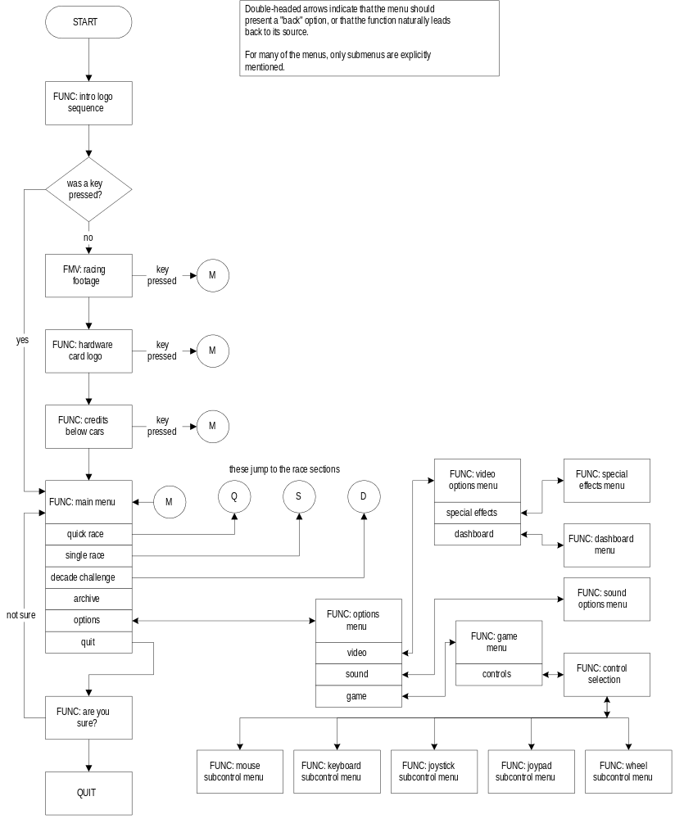

Quick Race and Single Race Flow Diagram

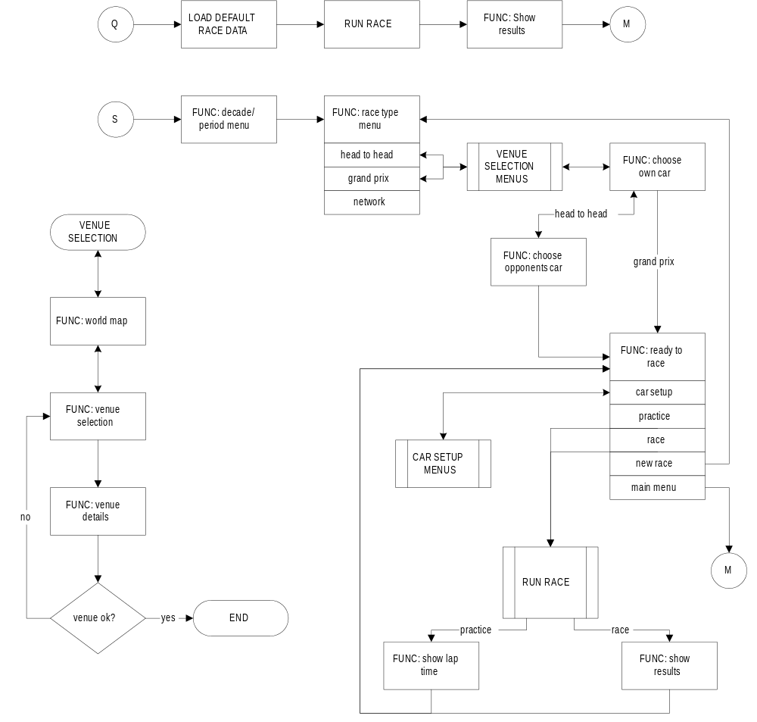

‘Decade Challenge’ Flow Diagram

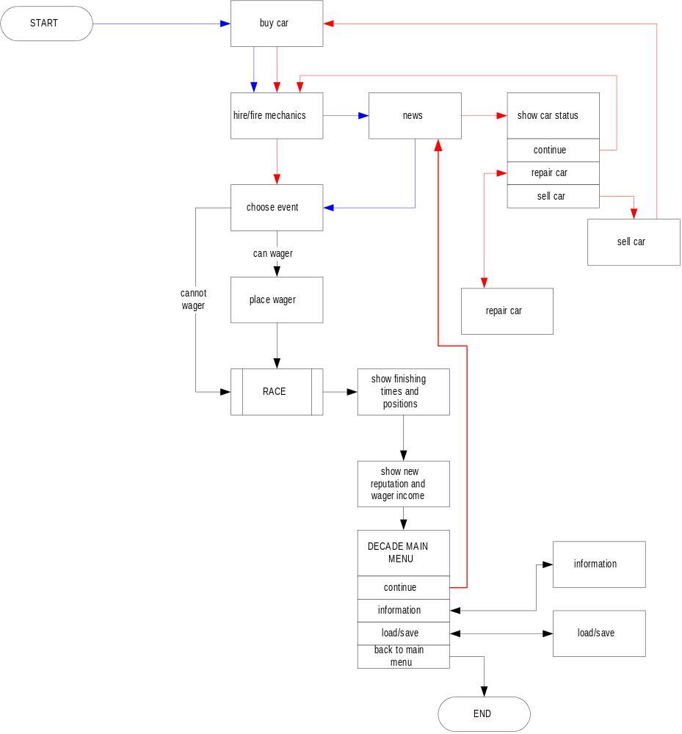

Load/Save Code
There are effectively two sets of data which are loaded and saved - options, quick race defaults and decade challenge data.

Options
This data is saved in the registry automatically whenever the Options menu subtree is left, and loaded when the game starts. It contains all the options information.

Quick race defaults
This data is saved in the registry automatically after each Single Race (except for network games). It’s then loaded when Quick Race is selected. It consists of:

- venue and year
- mode (Head to Head or Grand Prix)
- player’s car (and opponent’s car for Head to Head)
- car setup

Decade Challenge data
This data is saved in a file on the user’s hard disk, and is made up of a number (to be decided) of slots. Each of these slots has a name, and consists of the following data (this is liable to change):

- player’s name, current venue, budget and reputation
- player’s car data
- list of the player’s mechanics and their statistics
- list of the other computer-controlled players and their reputations and cars

Physics and Controllers
This part of the program is currently in flux, and will be documented fully soon.

The cars in the game exist object of class CarObject, a subclass of PhysObject, which is itself a subclass of BroadObject with physics properties.

CarObject contains the necessary information for producing forces from the engine and passing them through the transmission and steering mechanisms to the wheels, as well as more advanced collision code than that used by ordinary PhysObject objects.

Each car is attached to some subclass of Controller, which produces control packets from either the player, the network or the AI. The car responds accordingly in response to these control packets.
Unlike normal PhysObjects, cars are made up of a number of objects with a common parent, allowing each part of the car to be moved independently. Each type of car can be divided into different sections, although all cars must have a body, four wheels, and a collision hull. The physics of the car, and the parts of the car and how they fit together and handle damage are all defined in a parameter file:

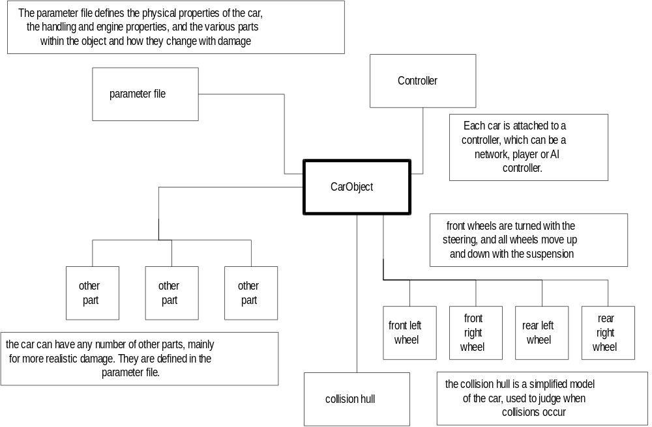

CarObjects are controlled by the player, the AI, and the network through the Controller mechanism:

Controller
This object sends control packets on request to a CarObject.This is a virtual base class - objects of this class don't really exist, just members of the three subclasses. Each subclass handles a different sort of control method - but the car object itself doesn't necessarily know what it's being controlled by. As far as it's concerned, it has a pointer to a Controller, it doesn't know what sort.

LocalController::Controller
This is an abstract subclass of Controller, with the exception that it knows how to send packets to other machines in a network game. All packets generated by LocalController subclasses are also sent to the network.

PlayerController::LocalController
This LocalController generates a single control packet per Tick from player input - keyboard, joystick, mouse or wheel. It’s only used by the CarObject which represents the player.

AIController::LocalController
This LocalController uses the artificial intellegence algorithms to generate one control packet per Tick.

NetController::Controller
This Controller generates its control packets from the network, queueing as many control packets as arrived between the last Tick and the current one. Because it is not a LocalController, it does not send any packets to the network - it just receives them.

Network Code
This has yet to be designed

Race Statistics Code
This has yet to be designed

‘Dashboard’ Code
The ‘dashboard’ consists of the images which are overlaid on the screen during the actual race. They take one of two forms:

- The ‘in-car’ view, where the car cockpit is rendered, and the controls in the cockpit reflect the state of the car;
- The ‘out of car’ view, where the state of the car is rendered onto the screen directly.

In the in-car view, there will still be some optional controls rendered onto the screen, such as position and lap times.

Data

The archive and archive stack
Files in the game are stored in a stack of file archives. When a file is requested, the top archive is searched first, followed by the archives below in sequence. When an archive is loaded, only its index block is stored in memory - the data for the files is only loaded when requested.

How models are stored
A full model usually consists of several files - a model description file and several Mulder files. The MDF is an ASCII file which describes which Mulder files are used at which distances. For example, an MDF for the model ‘car4’ would be called ‘car4’ and might look like (excepting the comments in italic):

car4-close 0.0 use when distance squared is 0 - 10
car4-middle 10.0 use when distance squared is 10 - 50
car4-far 50.0 use when distance squared is >50
end

The archive should then contain three Mulder files called car4-close, car4-middle and car4-far.

If, however, there is no MDF in the file, the model is assumed to have only one level of detail, and the name of the model is that of the single Mulder file for that level of detail.

txt-param files
Many items in the archive are txt-param files. These are ASCII files of the form:

# comment
key: string-value
key: string-value
# comment
key: string-value #comment
end

The archive management code will have special functions to allow the easy parsing of these files, which are a useful, general purpose way of storing parameters such as the physics parameters of cars. Note: a param file can contain several values with the same key; such as entries in a damage effect list (see below).

Archives loaded at the start of the game:
globalmodels.tc | contains the single LOD models which are used in every part of the game. Also contains the textures used by these models.
frontend.tc | contains language-independent BMPs, models, textures and text for the front end.
frontendlang.tc | contains BMPs, models, textures and text for the front end. There’s one of these for each language - only one is loaded.
gamelang.tc | contains text and other data for in-game stuff for each language. Only one of these is loaded.

Archives loaded for a particular race:
circuit.tc | The archive for this circuit (see below)
car.tc | One of these for each car present in this race

Circuit archives:
Each circuit has its own archive, which must contain the following:

file | format | description
circuit | vo-obj | Mulder file containing the track polygons
 | OR
circuit | txt-mdf | MDF file for the track polygons, describing circuit0-n.
circuit0-n | vo-obj | Mulder files for each level of detail
circuit | txt-scen | Scenery file constructed with SceneParse
circuit | txt-param | Physical parameters and other data for the track

In addition, a circuit archive may contain:
- local textures
- replacements for global textures (any textures with the same name as global textures will override them)
- local models
- replacements for global models

How the track is stored
The track is stored in two files : a Mulder object and a (probably converted into a proprietory format) Lightwave scene file. The Mulder object contains just the polygons for the track itself, while the scene file contains information about where to place scenery objects (which are separate objects) such as buildings and trees. In addition, the scene file contains 16 points describing where cars start on the grid.

The Scenery File and Grid Positions
The track scene file is generated from a .LWS (lightwave scene file) using a program called SceneParse, which can be found in the Boris directory. It contains the positions of objects which are to be generated as part of the scenery. This program normally saves object positions under the name that they have in the lightwave file (i.e. the full filename of the object), but this can be changed by giving each of these objects its own short name which will correspond to the name of the object.

There must be 16 grid positions, called “#Gn” where n is the grid number from 1 upwards. These can be created by dropping cars into the scene in Lightwave, and then editing the LWS file or the assignments in SceneParse.

Similarily, there should also be several camera positions, called “#Cn”. These can perhaps be created as very small objects - as with the grid positions, the models for these positions will never actually be used by the game. Note that the rotations are quite important for the cameras, since they define which way the camera is pointing.

Car archives:
Cars are different from other objects, in that they must be made of several components:
- the car body (in several sections)
- the wheels
- extra components, car dependent.

Each car has its own archive, which must describe these parts and how they fit together.

file | format | description
car | txt-scen | Scenery file constructed with SceneParse, describing the layout of the following objects within the car, relative to the object car-chassis. The list of parts in the car is implied by this file. Note that this means that the lightwave scene file will have to be edited a bit before being SceneParse’d.
car-part | txt-param | Describes the properties, including the model, of each part of the car. These must include car-wheelLF, car-wheelRF, car-wheelLB and car-wheelRB. See below.
car-part | txt-mdf | The model description file for the part. Obviously, the actual Mulder models should be in the file too.
car-physics | txt-param | physical (and other) parameters of the car

Car part files [this section subject to change]
As has already been noted, cars are made up of a number of parts, each of which has a model and a part parameter file. The parameter file names the model used by the part, and how the part behaves when it is damaged. This information consists of:

- model name
- under which conditions the part suffers damage
- the effect of any damage on the car’s physics
- the effect of any damage on the appearance of the part.

The file is in the form of a parameter file, which must at least specify the model name with a line of the form:

model: modelname

Damage condition clauses
If this part can suffer damage, you must write a damage condition clause - this defines under which conditions the object is likely to suffer damage. There are two components to this: the general damage value, which defines how much the force of any collision affects the part; and the local damage values, which defines where the object is on the car so that collisions on that part of the car damage the object. For example:

damage-general-mult: 0.1
damage-local-longitude: 100
damage-local-latitude: 120
damage-local-spread: 10
damage-local-mult: 0.8

means that the general damage value multiplier of 0.1, and the local damage takes place at 100° by 120° (cylindrical coordinates) with a spread of 10° either side with a multiplier of 0.8. Note that the default values for the multipliers is 0, which means that no damage affects the part.

When a car is hit, the following takes place:

for each part
general_damage = damage-general-mult * total_collision_force

work out local_collision_force, the amount of collision felt by the part
of the car which is within damage-local-spread degrees of the point of the car
sphere specified by damage-local-longitude and damage-local-latitude

local_damage = damage-local-mult * local_collision_force

total_damage = local_damage + general_damage

toughness = toughness - total_damage see below for toughness
do_damage_processing(toughness) see below for damage processing
endfor

Damage processing
Each part has a toughness value (default 100) determined by a parameter entry of the form:

toughness: 100

This value is decremented within the game each time the part is damaged, and if it has decreased damage processing occurs. This has two parts: physical damage effects, which describe the effects of the damage on the car physics; and visual damage effects, which describe what happens to the model of that part.

All effects are in the form of a list of values in the parameter table, giving the toughness threshold at which the effect occurs; for example:

numdams: 6 # number of effects in list
damage50: Mcrump # replace with a model called ‘crump’ at toughness=50
damage50: Pfoo~10 # decrement physics param ‘foo’ by 10 at toughness=50
damage20: Mbroken # replace with a model called ‘broken’ at toughness=20
damage20: Pfoo~90 # decrement physics param ‘foo’ by 90 at toughness=20
damage0: DROP # when toughness=0 make the item fall off
damage0: Pfoo=0 # and set foo to 0.

Physical damage effects
Physical effects are of the form

Pvaluename operation number

(without the spaces) where valuename is the name of an internal physics parameter (yet to be defined). The operations are the four standard arithmetic operators, along with the equals operator to set a value and the special ‘~’ operator, which decrements and clips to zero.

Visual effects
There are three visual effects:

- Mmodelname will replace the model used to render the part with another model;
- DESTROY will make the part vanish;
- DROP will make the part fall off the car, becoming an independent object. The object will probably also be made temporary, so that the track doesn’t become covered with discarded bits of cars.

Recapitulation
To recap, a car archive consists of
- car geometry, describing the layout of the parts
- car part models
- car part parameters, including damage actions

Appendix I - Interrupt Flowchart

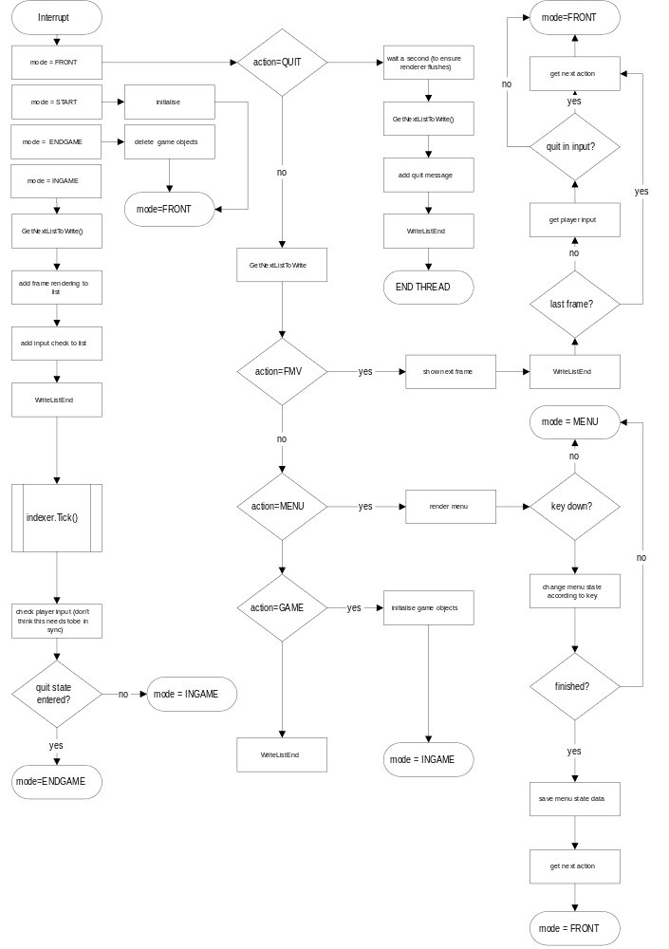

subject to change
See the Boris documentation

